**Instructions for downloading and installing R and RStudio. As well as Rtools and packages required for the workshop**

Please email Jason Doll [jason.doll@fmarion.edu](mailto:jason.doll@fmarion.edu) or call 843-661-1481, if you have any issues.

Visit the website below to install R and Rstudio.

<https://posit.co/download/rstudio-desktop/>

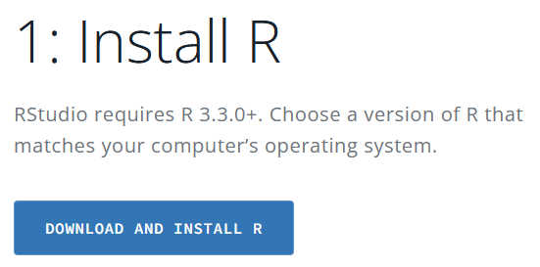**Step 1: Install R**

1. Click “DOWNLOAD AND INSTALL R” --------🡪
2. 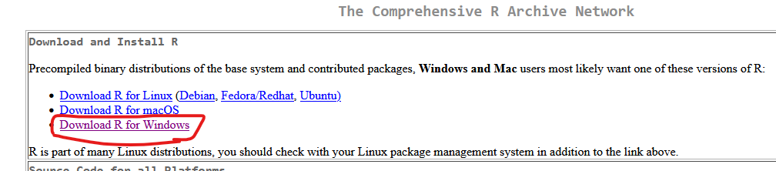You will be linked to the R webiste where you can select the R version for your operating sytem. The link for Windows is circled. Click “macOS” if you have a Mac
3. Select “install R for the first time 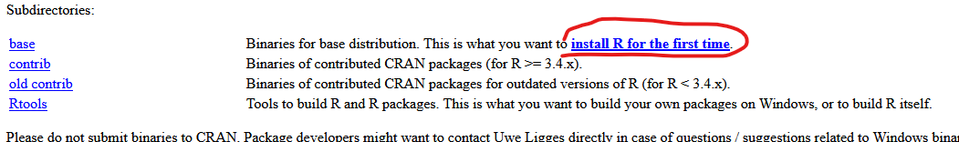
4. Select “Download R-4.3.2 for Windows”. Note the version number might be higher. Version 4.3.2 is the most recent version at the time of this writing (11/28/2023). Mac users will see a different screen. Find your version of Mac OS and click the installer for that version. 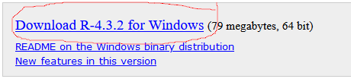
5. The installation file will download to your default download location. This is typically the “Download” folder for Windows. Open the installer and follow the installation prompts, accepting the default selections.

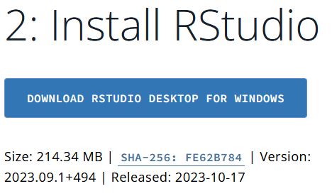**Step 2: Install RStudio Desktop**

<https://posit.co/download/rstudio-desktop/>

1. Click “DOWNLOAD RSTUDIO DESKTOP FOR WINDOWS”
2. This will download the installer.
3. Open the installer and follow the installation prompts. Accept all defult options.

**Step 3: Install Rtools**

You must have the most updated version of R to install Rtools43. If you have an earlier version, email me and I can walk you through alternatives. Rtools is needed to install and compile one of the R packages

*Windows users:*  
<https://cran.r-project.org/bin/windows/Rtools/rtools43/rtools.html>

Find and click “Rtools43 installer” in the middle of the screen. Install the file with default options selected.

*Mac users:*  
Install <https://mac.thecoatlessprofessor.com/macrtools/>

**Step 4: Install packages**

R packages needed for workshop

* FSA
* FSAdata
* ggplot2
* ggtext
* nlstools
* dplyr
* rstan
* brms

These packages can be installed with the following line of R code. Copy and past the line below into the R console and click “enter”. Some of these packages will take a few minutes to compile and install.

##Begin R Code##

install.packages( c("FSA", "FSAdata", "ggplot2", "ggtext", "nlstools", "dplyr", "rstan", "brms"))

#End R Code